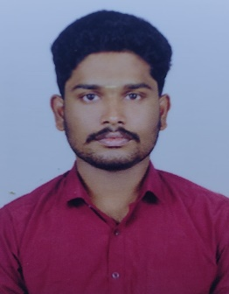 KARTIKEYAN A

**Linkedin:**<https://www.linkedin.com/in/kartikeyan-a-941b82267>

**Email:**[kartikeyan0002@gmail.com](mailto:kartikeyan0002@gmail.com)

**Address:**43/28 Keela vaikolkara Street, Woraiyur, Trichy-62003

**Mobile Number:** 6382618081

# Summary

Dedicated front-end developer with a passion for creating seamless and visually appealing user experiences. Leveraging strong proficiency in **HTML, CSS, and JavaScript**, **React** I aim to contribute innovatively.

solutions and collaborate on dynamic projects to drive web development excellence.

# Education skills

.

## Bharathidasan University Master of Computer Application

2021 - 2023 CGPA-7.1/10.00

**Bishop Heber College Bachelor of Computer Science**

2018 - 2021 CGPA–7.6 /10.00.

## 

## K A P Viswanathan higher secondary school

2017- 2018 **Higher Secondary School Education**

Percentage: 59%

## K A P Viswanathan higher secondary school

2015– 2016 **Senior Secondary School Education**

Percentage: 76%

# Skills

Html, CSS, JavaScript, React

**Languages:** Tamil (Native), English (Proficient), Hindi (Proficient)

# Certificate

HTML, CSS, JavaScript (completed in Udemy)

# Experience

**VeriTech Technology Pvt Ltd – Remote (16/01/24 to 16/04/24)**

• Every day, I actively engaged in continuous learning, applying my knowledge hands-on.

• I excelled as a collaborative team player and effective communicator with different team like

backend and UI team for understand project and build throughout my web development.

• One notable achievement was the successful development of a comprehensive E-Commerce.

website using HTML, CSS, JavaScript by the end of the internship.

# Responsive OTT, Food App ______________________________________________________

• Created a static restaurant website using HTML, CSS, and JavaScript.

• Designed an intuitive user interface for easy navigation.

• Incorporated a responsive design for seamless viewing on various devices.

• Demonstrated skills in front-end development and design.

# Project

**Online Tender Management System.**

* Certification for Intern Online Tender Management System

Project Using PHP & MySQL Language

**A Single Web Portal for Home Appliances**.

* Certification for intern A Single Web Portal for Home Appliances

Project Using Python Language.

DECLARATION:

ALL THE ABOVE FURNISHED INFORMATION IS TRUE TO MY KNOWLEDGE.

Regards,

Kartikeyan. A

+91 6382618081